**Part 1**

* **Crow’s foot notation:**
  + [**https://vertabelo.com/blog/crow-s-foot-notation/**](https://vertabelo.com/blog/crow-s-foot-notation/)
* **Many-to-Many relationships:**
  + [**https://blog.devart.com/how-to-create-many-to-many-relationships-between-tables.html**](https://blog.devart.com/how-to-create-many-to-many-relationships-between-tables.html)
* **PostgreSQL data types for columns:**
  + [**https://www.postgresqltutorial.com/postgresql-tutorial/postgresql-data-types/**](https://www.postgresqltutorial.com/postgresql-tutorial/postgresql-data-types/)
* **Downloading PostgreSQL:** [**https://www.youtube.com/watch?v=0n41UTkOBb0**](https://www.youtube.com/watch?v=0n41UTkOBb0)
* **Connecting to a .tar file for a DB in pgadmin:** [**https://www.youtube.com/watch?v=obnRGVXmeyE**](https://www.youtube.com/watch?v=obnRGVXmeyE)
* **Install Git on a mac:** [**https://www.youtube.com/watch?v=hMEyBtsuAJE**](https://www.youtube.com/watch?v=hMEyBtsuAJE),
* <https://medium.com/@carlosdevpereira/git-series-installing-git-e6d3ebfc40e3>

[**https://www.youtube.com/watch?v=ZM3I16Z-lxI**](https://www.youtube.com/watch?v=ZM3I16Z-lxI)**,**

[**https://www.youtube.com/watch?v=F02LEVYEmQw**](https://www.youtube.com/watch?v=F02LEVYEmQw)

* **Download page for postgresql:** [**https://www.postgresql.org/download/**](https://www.postgresql.org/download/)
* **Installing Git on a PC:** [**https://git-scm.com/**](https://git-scm.com/)
* **Github desktop:** [**https://desktop.github.com/**](https://desktop.github.com/)
* **pgAdmin 4 (alternative download):** [**https://www.pgadmin.org/download/pgadmin-4-windows/**](https://www.pgadmin.org/download/pgadmin-4-windows/)
* **Uninstall postgresql: Windows:** [**https://commandprompt.com/education/how-to-uninstall-postgresql-from-windows/**](https://commandprompt.com/education/how-to-uninstall-postgresql-from-windows/)

**Mac**: <https://macpaw.com/how-to/uninstall-postgressql-mac>

* **Discussion on current version issues:** <https://stackoverflow.com/questions/76680641/loading-pgadmin-4-v7-4-while-opening-pgadmin>
* **Add new server:** <https://docs.bitnami.com/aws/apps/discourse/administration/configure-pgadmin/#:~:text=Launch%20pgAdmin%204.,%E2%80%9CCreate%2DServer%E2%80%9D%20window>.

**Part 2**

* **Major actions in SQL:** [**https://www.w3schools.com/sql/default.asp**](https://www.w3schools.com/sql/default.asp)
* **JOINS:**[**https://www.geeksforgeeks.org/sql-join-set-1-inner-left-right-and-full-joins/**](https://www.geeksforgeeks.org/sql-join-set-1-inner-left-right-and-full-joins/)
* **More JOINS:** [**https://www.youtube.com/watch?v=RehbnzKHS28**](https://www.youtube.com/watch?v=RehbnzKHS28)
* **Any vs. All:** [**https://www.w3schools.com/sql/sql_any_all.asp**](https://www.w3schools.com/sql/sql_any_all.asp)

**Part 3**

* **WHERE vs. HAVING:** [**https://365datascience.com/tutorials/sql-tutorials/sql-where-or-having/**](https://365datascience.com/tutorials/sql-tutorials/sql-where-or-having/)
* **SQL CUBE:** [**https://www.sqltutorial.org/sql-cube/**](https://www.sqltutorial.org/sql-cube/)
* **UNION:** [**https://www.programiz.com/sql/union**](https://www.programiz.com/sql/union)

**Count(*) vs Count(*) performance:** [**Count(*) vs Count(1) - SQL Server - Stack Overflow**](https://stackoverflow.com/questions/1221559/count-vs-count1-sql-server?noredirect=1&lq=1&answertab=modifieddesc#tab-top)

**SQL interpreter order of operations/execution**

* **FROM and JOIN**
* **WHERE**
* **GROUP BY**
* **ROLLUP, CUBE, GROUPING SETS**
* **HAVING**
* **OVER (e.g., Window Functions)**
* **SELECT**
* **DISTINCT**
* **UNION, INTERSECT, EXCEPT**
* **ORDER BY**
* **OFFSET**
* **FETCH FIRST/NEXT ROWS ONLY, LIMIT, TOP**

**More in depth read:** [**https://vladmihalcea.com/sql-operation-order/**](https://vladmihalcea.com/sql-operation-order/)

**Part 4**

* **CTE’s:** [**https://www.postgresqltutorial.com/postgresql-tutorial/postgresql-cte/**](https://www.postgresqltutorial.com/postgresql-tutorial/postgresql-cte/)
* **Window functions:** [**https://en.wikipedia.org/wiki/Window_function_(SQL)**](https://en.wikipedia.org/wiki/Window_function_(SQL))
  + [**https://mode.com/sql-tutorial/sql-window-functions/**](https://mode.com/sql-tutorial/sql-window-functions/)
  + [**https://www.geeksforgeeks.org/window-functions-in-sql/**](https://www.geeksforgeeks.org/window-functions-in-sql/)
  + [**https://towardsdatascience.com/a-guide-to-advanced-sql-window-functions-f63f2642cbf9**](https://towardsdatascience.com/a-guide-to-advanced-sql-window-functions-f63f2642cbf9)
* **Case When:**
  + [**https://www.w3schools.com/sql/sql_case.asp**](https://www.w3schools.com/sql/sql_case.asp)
  + [**https://mode.com/sql-tutorial/sql-case/**](https://mode.com/sql-tutorial/sql-case/)
  + [**https://www.programiz.com/sql/case**](https://www.programiz.com/sql/case)
* **Phenomenal chat gpt convo**
  + [**https://chat.openai.com/share/c266041f-a315-4945-8abf-bfa8fb50ceb5**](https://chat.openai.com/share/c266041f-a315-4945-8abf-bfa8fb50ceb5)
* **Three valued logic**
  + [**https://modern-sql.com/concept/three-valued-logic**](https://modern-sql.com/concept/three-valued-logic)

**Cross Join idea:**

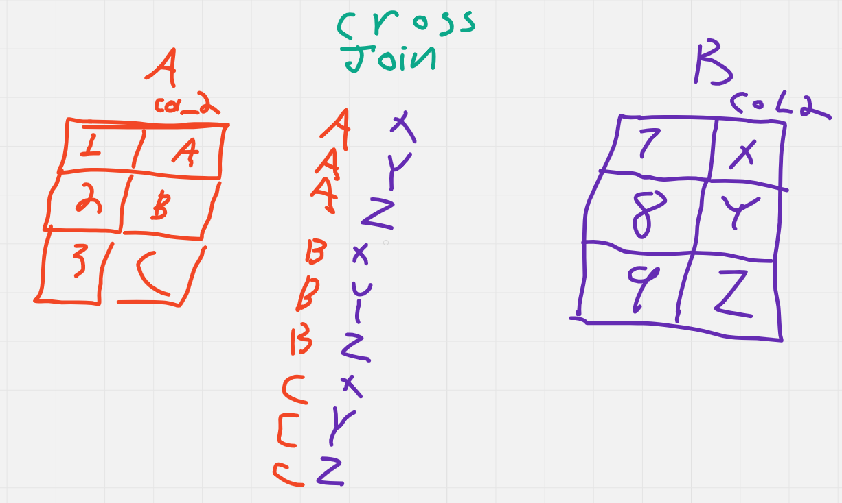

**Part 5**

* [**https://stackoverflow.com/questions/8584967/split-comma-separated-column-data-into-additional-columns**](https://stackoverflow.com/questions/8584967/split-comma-separated-column-data-into-additional-columns)
* [**https://www.sqlshack.com/string_agg-function-in-sql/**](https://www.sqlshack.com/string_agg-function-in-sql/)
* [**https://www.postgresqltutorial.com/postgresql-plpgsql/postgresql-create-function/**](https://www.postgresqltutorial.com/postgresql-plpgsql/postgresql-create-function/)
* [**https://medium.com/codex/weathering-the-sql-interpreter-13ebaa175955**](https://medium.com/codex/weathering-the-sql-interpreter-13ebaa175955)
* [**https://www.youtube.com/watch?v=BHwzDmr6d7s**](https://www.youtube.com/watch?v=BHwzDmr6d7s)

**Part 6**

* **Pivot in postgresql:** [**https://ubiq.co/database-blog/create-pivot-table-postgresql/**](https://ubiq.co/database-blog/create-pivot-table-postgresql/)
* **Views:** [**https://towardsdatascience.com/views-an-underrated-alternative-to-tables-in-sql-26cd6d1d8660**](https://towardsdatascience.com/views-an-underrated-alternative-to-tables-in-sql-26cd6d1d8660)
* **Recursion:** [**https://www.postgresqltutorial.com/postgresql-tutorial/postgresql-recursive-query/**](https://www.postgresqltutorial.com/postgresql-tutorial/postgresql-recursive-query/)
* [**https://www.postgresql.org/docs/current/queries-with.html#QUERIES-WITH-RECURSIVE**](https://www.postgresql.org/docs/current/queries-with.html#QUERIES-WITH-RECURSIVE)
* [**https://www.geeksforgeeks.org/postgresql-recursive-query/**](https://www.geeksforgeeks.org/postgresql-recursive-query/)
* [**https://elvisciotti.medium.com/postgresql-recursive-query-the-simplest-example-explained-f9b85e0a371b**](https://elvisciotti.medium.com/postgresql-recursive-query-the-simplest-example-explained-f9b85e0a371b)
* **LAG():** [**https://www.postgresqltutorial.com/postgresql-window-function/postgresql-lag-function/**](https://www.postgresqltutorial.com/postgresql-window-function/postgresql-lag-function/)

**DVD example showing where the join type will or will not matter for counting how many times a film in inventory has been rented.**

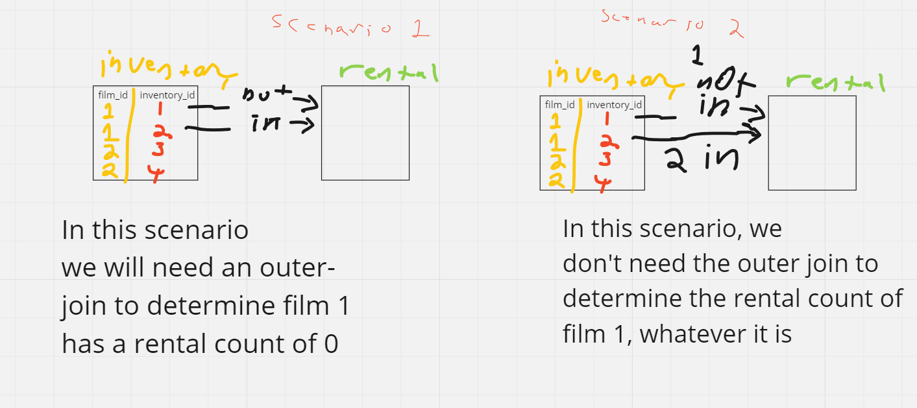

**Other:**

**Example Githubs:**

[**https://github.com/zapatos24/va02_volunteer_book**](https://github.com/zapatos24/va02_volunteer_book)

[**https://github.com/gordonkwokkwok/DVD-Rental-PostgreSQL-Project**](https://github.com/gordonkwokkwok/DVD-Rental-PostgreSQL-Project)

**Further SQL practice:**

[**https://mystery.knightlab.com/**](https://mystery.knightlab.com/)

[**https://sql-island.informatik.uni-kl.de/**](https://sql-island.informatik.uni-kl.de/)

[**https://sqlpd.com/**](https://sqlpd.com/)

[**https://www.edx.org/learn/relational-databases/stanford-university-databases-relational-databases-and-sql**](https://www.edx.org/learn/relational-databases/stanford-university-databases-relational-databases-and-sql)

**How to do Documentation for Postgresql DBs**

**Add it straight to the DB:**

[**https://dbschema.com/2020/07/14/postgres/documentation-tutorial/#:~:text=To%20document%20a%20PostgreSQL%20database,to%20access%20the%20PostgreSQL%20shell**](https://dbschema.com/2020/07/14/postgres/documentation-tutorial/#:~:text=To%20document%20a%20PostgreSQL%20database,to%20access%20the%20PostgreSQL%20shell)**.**